**Click4Biology: 2.2 Prokaryotic cells**

**Prokaryotic Cells**

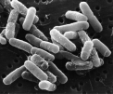A number of years ago two Norwegian biologists obtained a sample of soil from a nearby piece woodland. On returning to the laboratory they began to identify known species of prokaryote and also to classify any unknown species in their sample. By the time the two norwegians had finished they had doubled the entire catalogue of known prokaryotic species. The introduction to prokaryotes provided here is however based on perhaps the best know prokaryote *Escherichia coli (E. coli).*Notice that image of E. coli to the left shows a straight rod shaped cell. Other types of bacteria show different morphology some of these variations are shown in the table below.

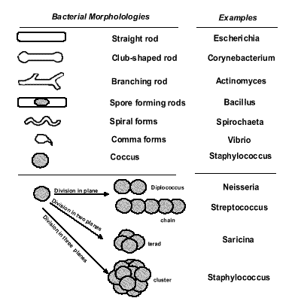

**2.2.1 Draw and label a diagram of the ultrastructure of Escherichia coli (E. coli) as an example of a prokaryote (1)**

Draw: To represent by means of pencil lines.

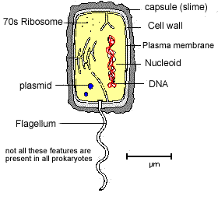The general size of a prokaryotic cell is about 1-2 um.

* Note the absence of membrane bound organelles
* There is no true nucleus with a nuclear membrane
* The ribosome's are smaller than eukaryotic cells
* The slime capsule is used as a means of attachment to a surface
* Only flagellate bacteria have the flagellum
* Plasmids are very small circular pieces of DNA that maybe transferred from one bacteria to another.

**2.2.2 Annotate the diagram from 2.2.1 with the functions of each named structure.**

Annotate: to add brief notes to a diagram or graph.

**Cell Wall:**

Made of a murein (not cellulose), which is a glycoprotein or peptidoglycan (i.e. a protein/carbohydrate complex). There are two kinds of bacterial cell wall, which are identified by the Gram Stain technique when observed under the microscope. Gram positive bacteria stain purple, while Gram negative bacteria stain pink. The technique is still used today to identify and classify bacteria. We now know that the different staining is due to two types of cell wall

**Plasma membrane:**

Controls the entry and exit of substances, pumping some of them in by active transport.

**Cytoplasm:**

Contains all the enzymes needed for all metabolic reactions, since there are no organelles.

**Ribosome:**

The smaller (70 S) type are all free in the cytoplasm, not attached to membranes (like RER). They are used in protein synthesis which is part of gene expression.

**Nucleoid:**

Is the region of the cytoplasm that contains DNA. It is not surrounded by a nuclear membrane. DNA is always a closed loop (i.e. a circular), and not associated with any proteins to form chromatin.

**Flagella:**

These long thread like attachments are generally considered to be for movement. They have an internal protein structure that allows the flagella to be actively moved as a form of propulsion. The presence of flagella tends to be associated with the pathogenicity of the bacterium. The flagella is about 20nm in diameter. This structure should not be confused with the eUkaryotic flagella seen in protoctista.

**Pilli:**

These thread like projections are usually more numerous than the flagella. They are associated with different types of attachment. In some cases they are involved in the transfer of DNA in a process called conjugation or alternatively as a means of preventing phagocytosis.

**Slime Capsule:**

A thick polysaccharide layer outside of the cell wall, like the glycocalyx of eukaryotes. Used for sticking cells together, as a food reserve, as protection against desiccation and chemicals, and as protection against phagocytosis. In some species the capsules of many cells in a colony fuse together forming a mass of sticky cells called a biofilm. Dental plaque is an example of a biofilm.

**Plasmids:**

* Extra-nucleoid DNA of up to 400 kilobase pairs. Plasmids can self-replicate particularly before binary fission.
* They are associated with conjunction which is horizontal gene transfer.
* It is normal to find at least one anti-biotic resistance gene within a plasmid. This should not be confused with medical phenomena but rather is an ecological response to other antibacterial compounds produced by other microbes. Commonly fungi will produce anti-bacterial compounds which will prevent the bacteria replicating and competing with the bacteria for a resource.

**conjugation**

* Direct contact between bacterial cells in which plasmid DNA is transferred between a donor cell and a recipient cell.
* There is no equal contribution to this process, no fertilisation and no zygote formation. It cannot therefore be regarded as sexual reproduction.

[**top**](http://click4biology.info/c4b/2/cell2.2.htm#top)

**2.2.3 Identify structures from 2.2.1 in electron m icrographs of E. coli (2).**

Identify: To find an answer from a given number of possibilities.

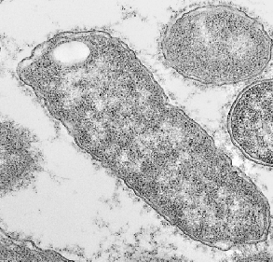

1. 1. Note the double membrane of this E. coli .

This feature means that the cells do not retain the dark blue stain used in microscopy. They are therefore known as Gram-negative this contrast with Gram-positive single membrane bacteria.

1. There is some evidence in the image of pilli which are the surrounding light grey masses.
2. In the cytoplasm of the bacterium there are no visible organelles which is consistent with how we expect a prokaryote cell to appear.
3. The nucleoid region is not seen well in this particular image but is clearer in the next image.

**2.2.4 State that prokaryotic cells divide by binary fission (1).**

State:means to give a specific name, value or **other brief answer** without explanation or calculation.

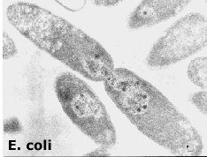

* Prokaryotic cells divide by binary fission.
* This is an asexual method of reproduction in which a 'parental' cell divides into two smaller but equally sized cells.
* The cells are genetically identical and form the basis of a reproductive clone.

The process of binary fission takes place in four stage:

**(a). Reproduction signa**l: The cell receives a signal, of internal or 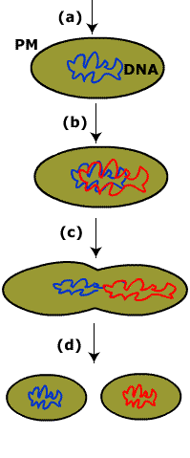external origin that initiates the cell division.

E.coli replicates about once every 40 minutes when incubated at 37o C. If however we increase the concentration of carbohydrate nutrients that the cell is supplied with then the division time can be reduced to 20 minutes. There is a suggestion here that an external signal (nutrient concentration) is acting as the reproductive signal.

**(b). Replication of DNA**: bacterial cells have a single condensed loop of DNA. This is copied by a process known as semi-conservative replication to produce two copies of the DNA molecule one for each of the daughter cells

The replication begins at a single point (*ori*)on the loop of DNA. The process proceeds around the loop until two loop have been produced, each a copy of the original. The process finishes at a single point on the loop of DNA called the *ter* position.

**(c). Segregation of DNA:** One DNA loop will be provided for each of the daughter cells.

As the new loops form the *ori*site becomes attached to some contractile proteins that pull the two ori sites, and therefore the loops, to opposite ends of the cell. This is an active process that requires the bacteria to use energy for the segregation.

**(d). Cytokinesis:**Cell separation.

This occurs once the DNA loop replication and segregation is complete. The DNA completes a process of condensing whilst the plasma membrane begins to form a 'waist' or constriction in the middle of the cell. As the plasma membrane begins to pinch and constrict the membrane fuses and seals with additional new membrane also being formed.